Visualisation and analysis

Duncan Golicher

1/4/2019

## Analysing the peak assemblage table

Table one was derived from applying a consistent algorithm to the pooled data. The abundances were summed over all the sites for each month for all of the 19 species. The maximum count, rather then the low water count was used in the case of the observations of dunlin in 2017/18. This was considered to most likely match the method used for the data that was obtained from previous years surveys. The species abundances were first summed over all sites to produce an assemblage count for all winter months. For each winter season the month with the maximum assemblage value was found. The abundances of each of the species recorded in this month was taken as a measure of their individual contributions to this peak assemblage. This is a consistent methodology. However it differs from the data tables produced in the report in 2017. In the previous analysis the peak species abundances referred to the maximum observed count across all the months of each season. A proportional contribution could not be calculated using this approach, as the sum of the species counts exceeded the total for the peak assemblage.

## Table of counts

The counts are presented in a spreadsheet format for pasting into Excel.

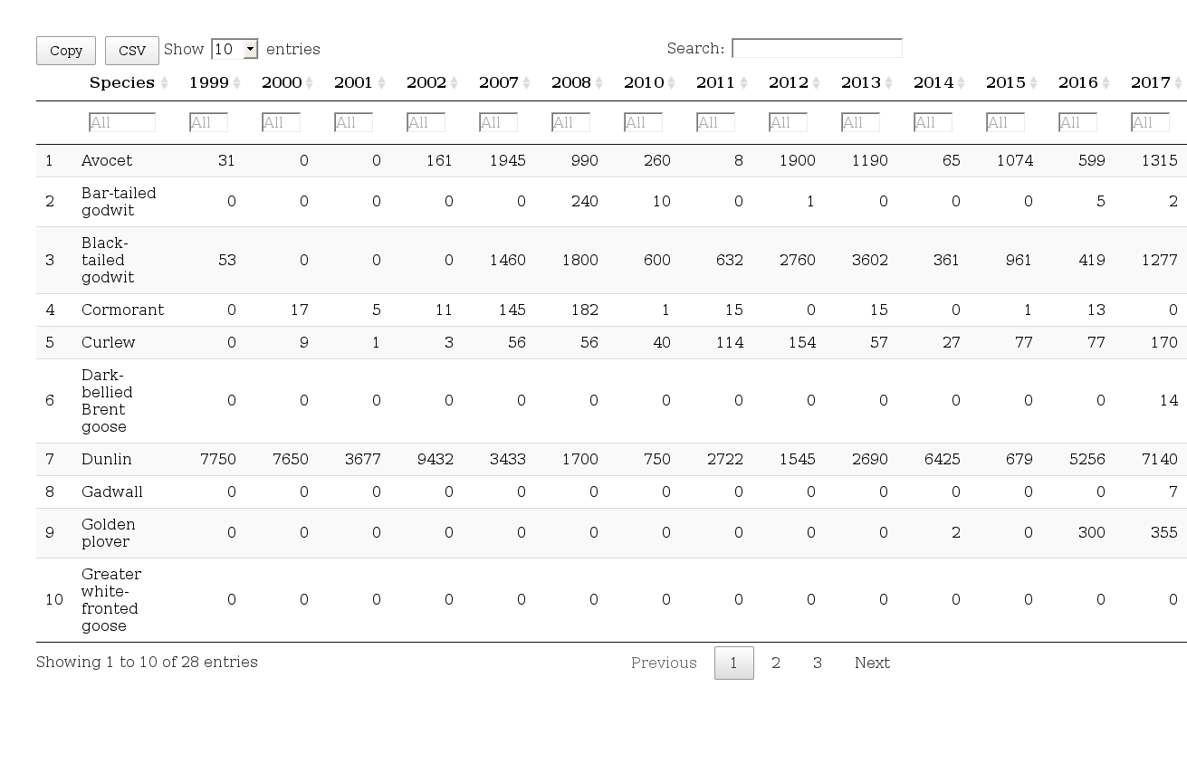

## Peak assemblage values

The sum of the counts in the table above is now equivalent to the peak assemblage counts.

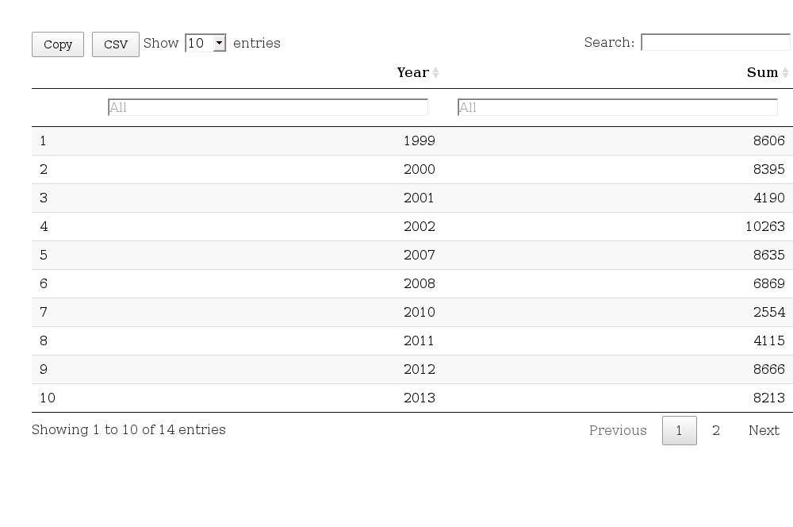

## Table of percent contribution to assemblage

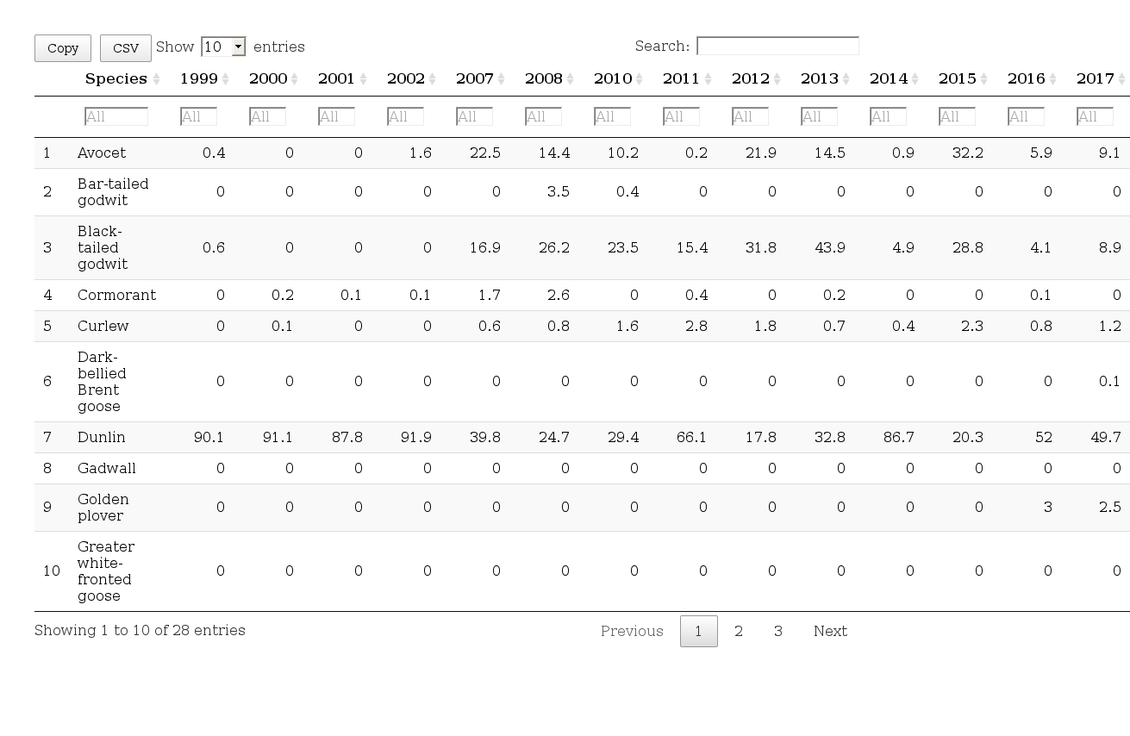

## Proportional contribution

Stacked bar charts show the proportional contributions to the peak assemblage for the top ten most abundant species. The rare species are not included in the total shown. They make a negliglible contribution in all years.

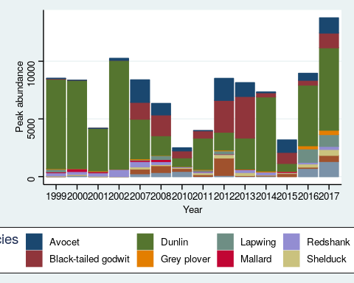

### Excluding Dunlin

As Dunlin dominate the counts in most years the data can also be shown as peak assamblage totals, excluding Dunlin.

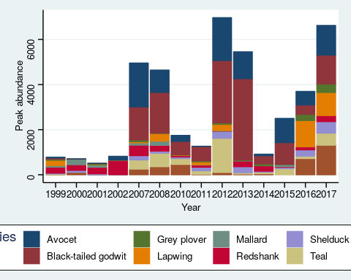

## Only top three species (Key species)

The top three most abundant species are Dunlin, Black-tailed godwit and Avocet.

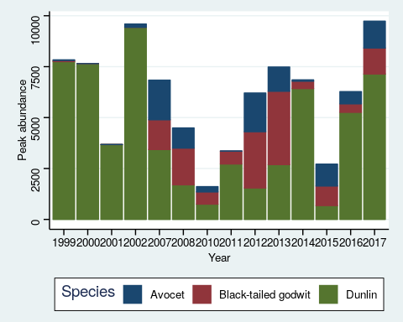

## Analysis of the peak aggregation

## Generalised linear models for trends

The use of regression as a method to formally analyse trends is greatly limited by the low sample size and by the high variability between count values. A longer time series of observations could show serial autocorrelation between the values forming a time series. Additional co-variates such as climatic effects might also be taken into account. As there are only a small number of data points available, a regression analysis could only provide evidence of a significant trend in the unlikely case of a monotonic year on year increase or decrease. In the case of counts that may take low numbers regression analysis using normally distributed errors may produce confidence intervals that fall below zero, which is impossible. Generalised linear models of the negative binomial family which account for overdispersion are prefereable in this case. Plotting lines derived from a negative binomial GLM with confidence intervals for the pre and post development periods shows no indication of such a consistent trend.

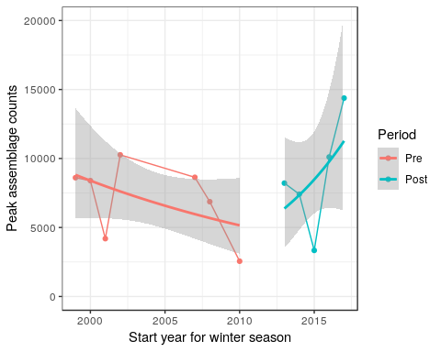

## Generalised linear model

The GLM equivalent of analysis of covariance can be used to test the strength of evidence provided for a difference in any overall trend lines in the pre and post development years. Given the very small sample size, the same caveats apply. Differences are unlikely to be detectable on such a short time scale. The parameter of interest is the interaction temr between period and year.

## Analysis of Deviance Table  
##   
## Model: Negative Binomial(6.781), link: log  
##   
## Response: Sum  
##   
## Terms added sequentially (first to last)  
##   
##   
## Df Deviance Resid. Df Resid. Dev Pr(>Chi)  
## NULL 11 16.420   
## Period 1 0.84453 10 15.576 0.3581  
## Year 1 0.58795 9 14.988 0.4432  
## Period:Year 1 2.69187 8 12.296 0.1009

No significant interaction effects is found, so the model provides no evidence of any difference in the trends before and after the works.

## Analysing differences in means before and after development

As there is no evidence of consistent trends, the variability between years can be treated as if the were a set of independent observations. This does not imply that there is no underlying relationship between the total population of birds in consecutive, simply that random variability due to movements of flocks and changes in the observability of the birds in combination with stochastic population fluctuations are adequate explanations for the observed variability.

In this case the period becomes a factor with two levels. Data can be visualised as boxplots and means with confidence intervals calculated from the variability around the mean values.

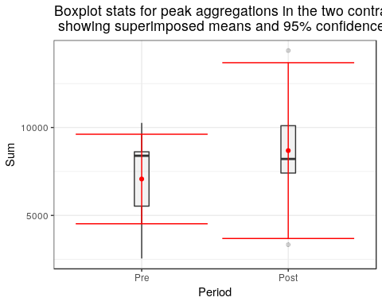

The significance of the differences between two means can be tested using an unpaired t-test.

##   
## Welch Two Sample t-test  
##   
## data: Sum by Period  
## t = -0.7768, df = 6.6254, p-value = 0.4641  
## alternative hypothesis: true difference in means is not equal to 0  
## 95 percent confidence interval:  
## -6590.732 3359.418  
## sample estimates:  
## mean in group Pre mean in group Post   
## 7073.143 8688.800

The t-test provides no evidence of a significant difference between the mean peak assemblages pre and post works (p = 0.46).

However there is an issue with regard to the interpretation of the result of such a test. Under null hypothesis significance testing (NHST) it is not possible to accept the null hypothesis of no difference. NHST simply fails to reject the null. The p value represents the probability of obtaining the data, or data more extreme, given that the null hypothesis is in fact true. However the precise point null hypothesis of exactly no difference between assemblage counts before and after the works is not a credible one. There must be some differences. The issue is whether any differences fall within acceptable bounds. Thus NHST is problematic when the decision rule in question involves looking at the evidence **in favour** of the null hypothesis. This is the case here as shown in the description of the decision rule provided in the report.

*The initial target against which the success of the mitigation and compensation will be assessed shall be that the sites in combination support an assemblage of wintering waterfowl at low tide comprising, on a 5-year mean peak basis at least* ***7900 birds*** *made up of, in particular, avocet, dunlin and black-tailed godwit in similar proportions to those supported by North Mucking during the winters of 1999/2000 to 2002/2003 (considered in the context of the wider population trends)*

The alternative to NHST is to adopt a Bayesian approach to inference. Under this approach he 5 year means for peak abundances are not considered to be fixed quantities, but are themselves treated as random variables with distributions. Bayes’ formula provides a formal mechanism of providing probabilities for unknown quantities of interest. In this case the difference between $μ_{1}$ and $μ_{2}$ (the mean peak assemblages before and after the works ) is an unknown quantity.

Bayes theorem states.

$p(θ|D)=\frac{p(D|θ)p(θ)}{p(D)}$ Where $θ=(μ_{1},μ_{2},σ_{1},σ_{2},v)$

So, the posterior credibility of the combination of values for $(μ_{1},μ_{2},σ_{1},σ_{2},v)$ is the likelihood of that combination times the prior credibility of the combination, divided by the constant p(D). When it is assumed that the data are independently sampled, the likelihood is the multiplicative product across all the data values of the probability density of a t distribution. The prior is the product of the five independent parameter distributions. The constant p(D) is the marginal likelihood, which may be obtained by integrating the product of the likelihood and prior over the entire parameter space. This integral is difficult to compute analytically. This difficulty limited the application of Bayesian methods before computational solutions using simulation became available. However this limitation no longer exists. It is now computationally simple to fit the true Bayesian model using tools supplied through R (Plummer 2018). This allows the full posterior distributions of the parameter values to be obtained, leading to a richer and more informative analysis (Kruschke 2013).

Providing that uninformative prior probabilities for the parameters are used, applying Bayes theorem in the context of a t-test will then provide credible intervals for the differences between means (Edwards 1996). Although the estimates may be numerically very similar to those derived from the confidence intervals of a traditional t-test, the interpretation of the result now directly maps onto the required decision rule.

The traditional t-test found that the best estimate for the pre-works mean as 7073 and the post works mean as 8689 giving a point estimate difference between the means of 1616.

The original target value of 7900 for the overall assemblage were derived from low water count data for the four winter periods 1999/2000 to 2002/2003. The pre works data used in the t-test included some additional observations as, These observations are helpful in establishing the range of variability for inference so have been included. If it were desirable these values could be excluded and the analysis re-run without them.

Bayesian model fitting allows a formal evaluation of a decision rule based on the concept of the **region of practical equivalence** (ROPE). This is an area around the null value of no difference which encloses those values of the parameter that are deemed to be not importantly different from the null value for the practical purposes of the study.

In this case any increase in assemblage numbers, even if not statistically significant, are of no practical importance in evaluating whether Clause 10.5.4 has been met. The ROPE can therfore extend to the right almost indefinitely. The choice of a left hand boundary for the ROPE has to be considered through a careful evaluation of the available data. The target value was originally set at around 8000 birds. This is around 1000 higher than the first estimate of the pre-works mean. It would thus seem reasonable to set a ROPE lying between -1000 and 1000.

The bayesian t-test is then run using the package BEST {Kruschke and Meredith (2018)} in R. The model used completely non-informative vague priors for the parameters of interest in order to avoid subjectivity. The resulting simulation provided the full posterior distribution for the differences between the two means.

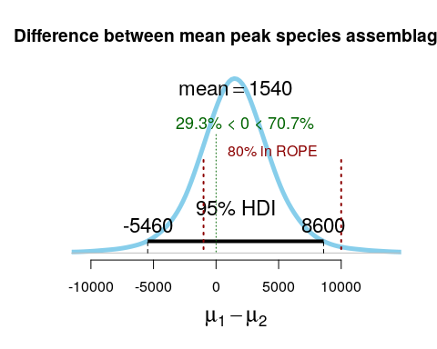

The figure shows the full posterior distribution for the difference between the two means, which is treated as a random variable and takes a t-distribution. The interpretation of the figure in terms of a decision rule of the Bayesian t-test analysis is clear when the ROPE is superimposed on the distribution. Around 80% of the posterior distribution for the difference between the two means lies within the ROPE. Although this does imply that there is a 20% chance that the value could stil lie outside the ROPE, the analysis is still being based on limited data. Intuitively it would be impossible to decide with certainty that the criteria had been met based on many fewer data points. The analysis formalises the strength of the currently avaialable evidence. As more data becomes available the probability that the criteria would be met becomes higher. Bayesian analysis allows for updating posterior distributions through additional data.

## Analysis for key species

### Dunlin

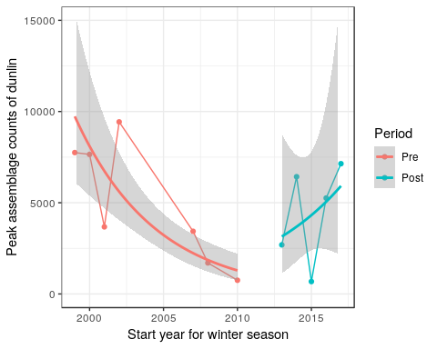

In the case of Dunlin the GLM analysis does suggest a steady and signficant pre works decline in numbers (p<0.01) between 1998 and 2010. However there is no indication of a trend post works.

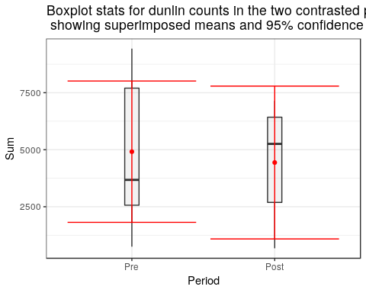

##   
## Welch Two Sample t-test  
##   
## data: Sum by Period  
## t = 0.27169, df = 9.7662, p-value = 0.7915  
## alternative hypothesis: true difference in means is not equal to 0  
## 95 percent confidence interval:  
## -3434.144 4384.429  
## sample estimates:  
## mean in group Pre mean in group Post   
## 4913.143 4438.000

A traditional t-test provides no evidence of a significant differences between the means (p = 0.79). .

### Bayesian t-test for Dunlin

As Dunlin numbers actually declined in the period prior to the construction, the ROPE for Dunlin should include this as a consideration. The region of practical equivalence thus includes a reduction of -3000 for this species.

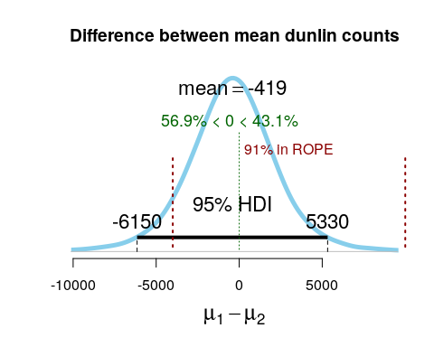

The analysis shows that around 90% of the posterior distribution falls within the ROPE. Thus there is very strong evidence that the works have had no practical impact on overall dunlin numbers.

### Black tailed godwit

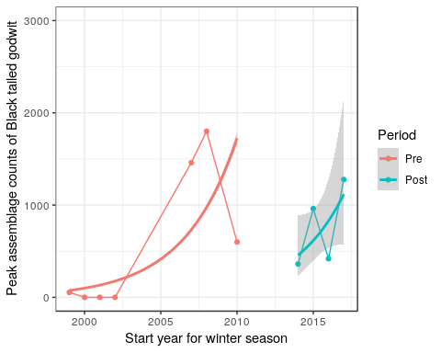

In the case of Black tailed godwit the GLM analysis does suggest a highly signficant pre works increase in numbers (p<0.001) between 1998 and 2010. However there is no indication of a trend post works.

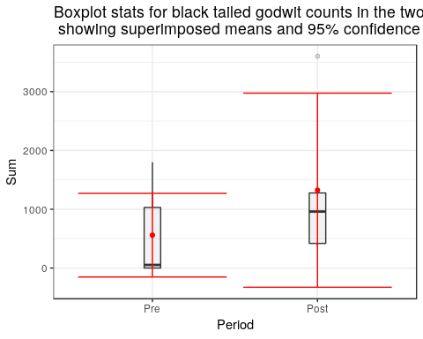

##   
## Welch Two Sample t-test  
##   
## data: Sum by Period  
## t = -1.156, df = 5.9146, p-value = 0.2922  
## alternative hypothesis: true difference in means is not equal to 0  
## 95 percent confidence interval:  
## -2389.9715 859.9715  
## sample estimates:  
## mean in group Pre mean in group Post   
## 559 1324

A traditional t-test provides no evidence of a significant differences between the means (p = 0.29). However in this case the analysis is problematic, as the low counts lead to confidence intervals that fall below zero. A more robust analysis would be based on an overdispersed poisson, i.e a negative binomial distribution. For the sake of consistency this statistical detail will be ignored, but it should be noted that it has been recognised as an issue.

### Bayesian t-test for Black tailed godwit

As the black tailed godwit numbers increased in the period prior to the construction, the ROPE for them should include this as a consideration. The region of practical equivalence thus includes a reduction of -3000 which is approximately the difference between peak numbers prior to works and low numbers in 1998) for this species. This is similar to the analysis used for Dunlin, although the variability pre works followed the reverse trend.

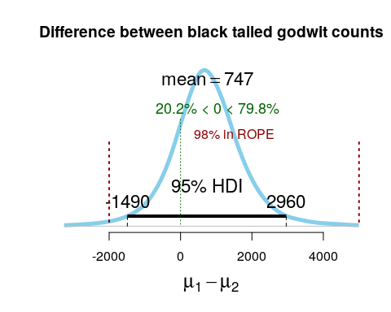

In this case a small amount (around 2%) of the ROPE actually falls below the posterior 95% highest density interval for the differences between the two means. The practical equivalence criteria is met to a very high degree of certainty, given the addditional evidence that black tailed godwit numbers have significantly increased over the period from 1998.

## Avocet

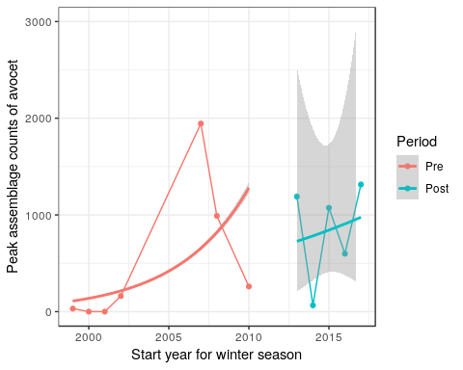

In the case of Avocet the GLM analysis does also suggest a highly signficant pre works increase in numbers (p<0.001) between 1998 and 2010. However once again, there is no indication of a trend post works.

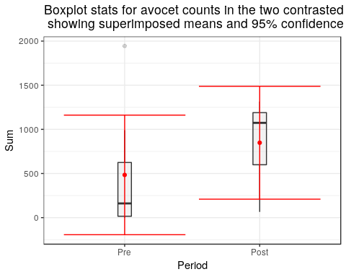

##   
## Welch Two Sample t-test  
##   
## data: Sum by Period  
## t = -1.0128, df = 9.9965, p-value = 0.335  
## alternative hypothesis: true difference in means is not equal to 0  
## 95 percent confidence interval:  
## -1167.2154 437.7296  
## sample estimates:  
## mean in group Pre mean in group Post   
## 483.8571 848.6000

The traditional t-test agin provides no evidence of a significant differences between the means (p = 0.34). The caveats mentioned for black tailed godwit apply, and the increasing trend has not been taken into account.

### Bayesian t-test for Avocet

As avocet counts increased in the period prior to the construction, the ROPE for them should include this as a consideration, as for black tailed godwit. The region of practical equivalence thus includes a reduction of -1500 which is approximately the difference between peak numbers prior to works and low numbers in 1998) for this species.

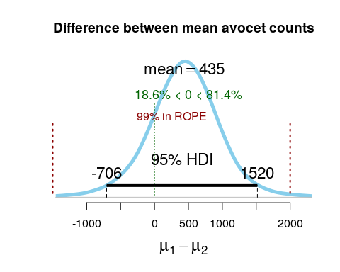

The practical equivalence criteria is again met to a very high degree of certainty, given the addditional evidence that avocet numbers have significantly increased over the period from 1998.

## Differences in proportional abundance

The target goal was also stated in terms of proportional abundance. *At least 7900 birds made up of, in particular, avocet, dunlin and black-tailed godwit in similar proportions to those supported by North Mucking during the winters of 1999/2000 to 2002/2003*

Inspection of the stacked bar charts and the raw data shows that the proportion of dunlin in the assemblage was higher between 1999 and 2002 than at present. As dunlin are small common waders a decrease in their proportional contribution would be interpreted as a positive effect, rather than a negative one.

Changes in proportional abundance of dunlin.

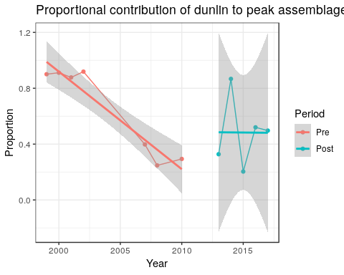

## Trend analysis for proportional abundance of dunlin using beta regression

In order to establish the signficance of the change generalised linear modelling based on the beta distribution would provide the most robust approach. Proportions cannot be modelled with normally distributed errors. The betareg package in R allows this {Grün et al. (2012)}

### Yearly trend

##   
## Call:  
## betareg(formula = Proportion ~ Year, data = dunlin)  
##   
## Standardized weighted residuals 2:  
## Min 1Q Median 3Q Max   
## -1.5243 -0.9514 0.3101 0.6394 2.1324   
##   
## Coefficients (mean model with logit link):  
## Estimate Std. Error z value Pr(>|z|)   
## (Intercept) 210.8212 84.1799 2.504 0.0123 *  
## Year -0.1048 0.0419 -2.501 0.0124 *  
##   
## Phi coefficients (precision model with identity link):  
## Estimate Std. Error z value Pr(>|z|)   
## (phi) 4.299 1.625 2.646 0.00815 **  
## ---  
## Signif. codes: 0 '***' 0.001 '**' 0.01 '*' 0.05 '.' 0.1 ' ' 1   
##   
## Type of estimator: ML (maximum likelihood)  
## Log-likelihood: 3.661 on 3 Df  
## Pseudo R-squared: 0.439  
## Number of iterations: 141 (BFGS) + 4 (Fisher scoring)

Beta regression produces evidence of a statistically signficant (p=0.012) reduction in the proportional contribution of dunlin to the species assemblage between 1999 and present. However the trend occurred prior to the works cmencing.

## Changes in species diversity

Although the criteria used to evaluate the impact of the works aimed to ensure a comparable mix of species abundances, the decline in relative abundance of dunlin and the increase in the relative contribution of other species may have increased species diversity. This is generally considered to be a positive outcome for conservation.

In order to evaluate changes in species diversity a commonly used diversity index was calculated for the assemblage. Shannnon’s index is based on proportional contributions of each species to the assemblage.

$H=−\sum_{i=1}^{N}{p_{i}}ln(p_{i})$

Where $p_{i}$ is the proportional abundance of each species in an assemblage consisting of N species.

Shannon’s index was calculated by transforming the table of counts into a matrix and applying the diversity function in the R package vegan {Oksanen et al. (2018)}

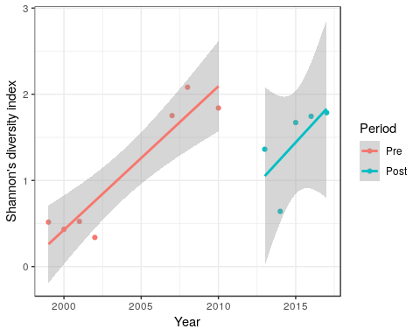

## Changes in mean Shannon’s index

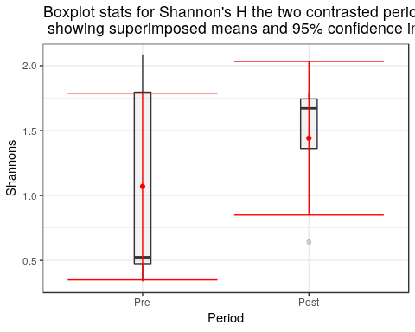

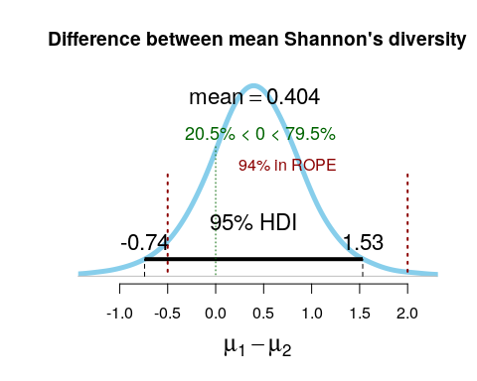

## References

Edwards, D. 1996. Comment: The first data analysis should be journalistic. ECOLOGICAL APPLICATIONS 6:1090–1094.

Grün, B., I. Kosmidis, and A. Zeileis. 2012. Extended beta regression in R: Shaken, stirred, mixed, and partitioned. Journal of Statistical Software 48:1–25.

Kruschke, J. K. 2013. Bayesian estimation supersedes the T test. Journal of Experimental Psychology: General 142:573–588.

Kruschke, J. K., and M. Meredith. 2018. BEST: Bayesian estimation supersedes the t-test.

Oksanen, J., F. G. Blanchet, M. Friendly, R. Kindt, P. Legendre, D. McGlinn, P. R. Minchin, R. B. O’Hara, G. L. Simpson, P. Solymos, M. H. H. Stevens, E. Szoecs, and H. Wagner. 2018. Vegan: Community ecology package.

Plummer, M. 2018. Rjags: Bayesian graphical models using mcmc.