Styling and cartography
Duncan Golicher
9/10/2018

Introduction
Although the use of “slipppy”, zoomable, web maps to embed within webpages has now become a key part of GIS, traditional maps that can be printed out and included in paper based reports and posters are still useful. In this class we will look at how QGIS can be used in this context to form a phase one map that could be given to visitors to Hengistbury head.
We will start with a digitised map consisting of polygons. For the purposes of illustration I have simply drawn a few polygons on screen to illustrate the concepts. Your own map will look very different from the one shown in the handouts, but the instructions will work in the same way with any set of polygons. For the assignment you will rpoduce your own phase one map and canuse these steps to shade it in with the conventional colour scheme.

Using a prebuilt style
This is my example, blank map with no styling.
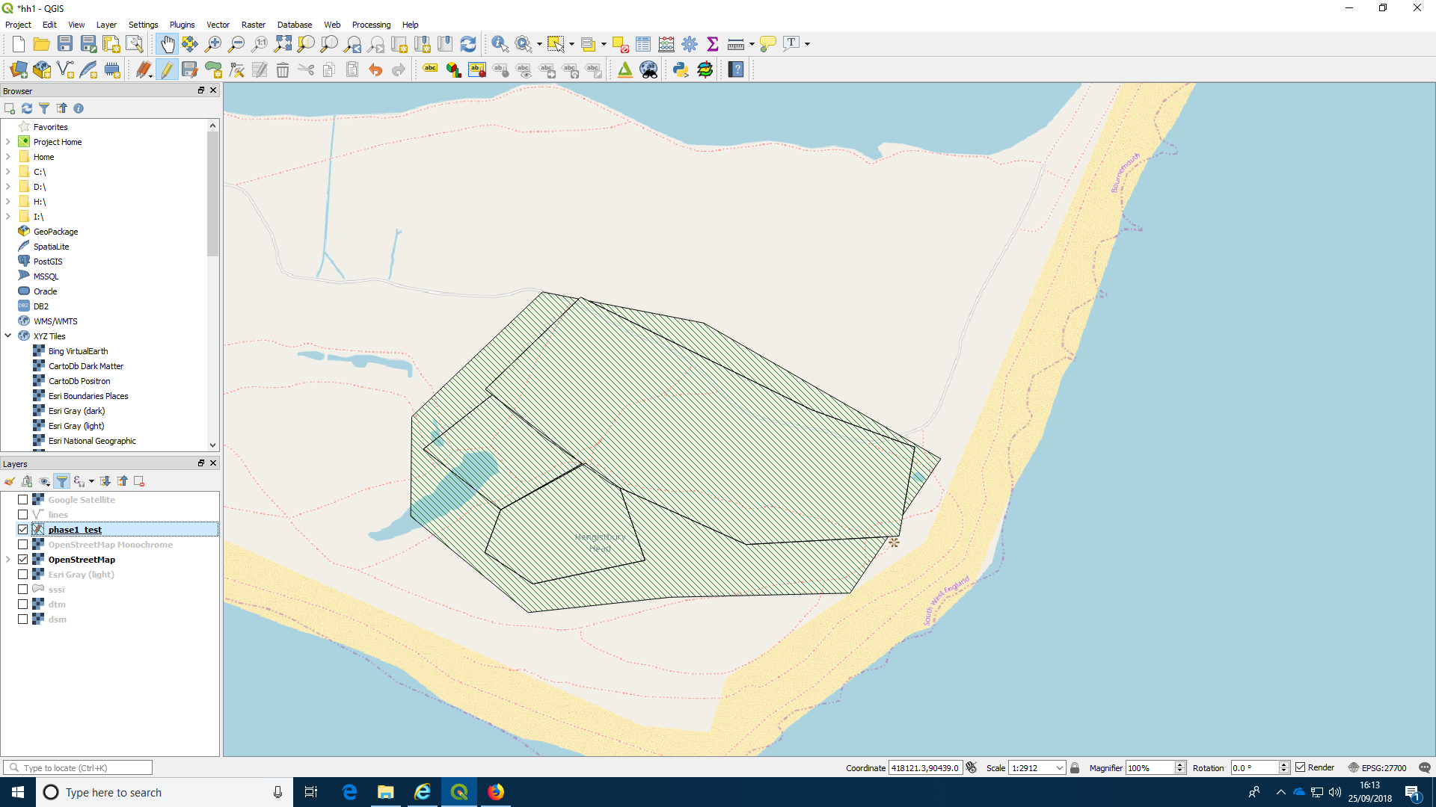

Finding the styling dialogue
Right clicking on the layer name in the layers panel will bring up a menu which includes the properties tab (don’t click on styles at this point).
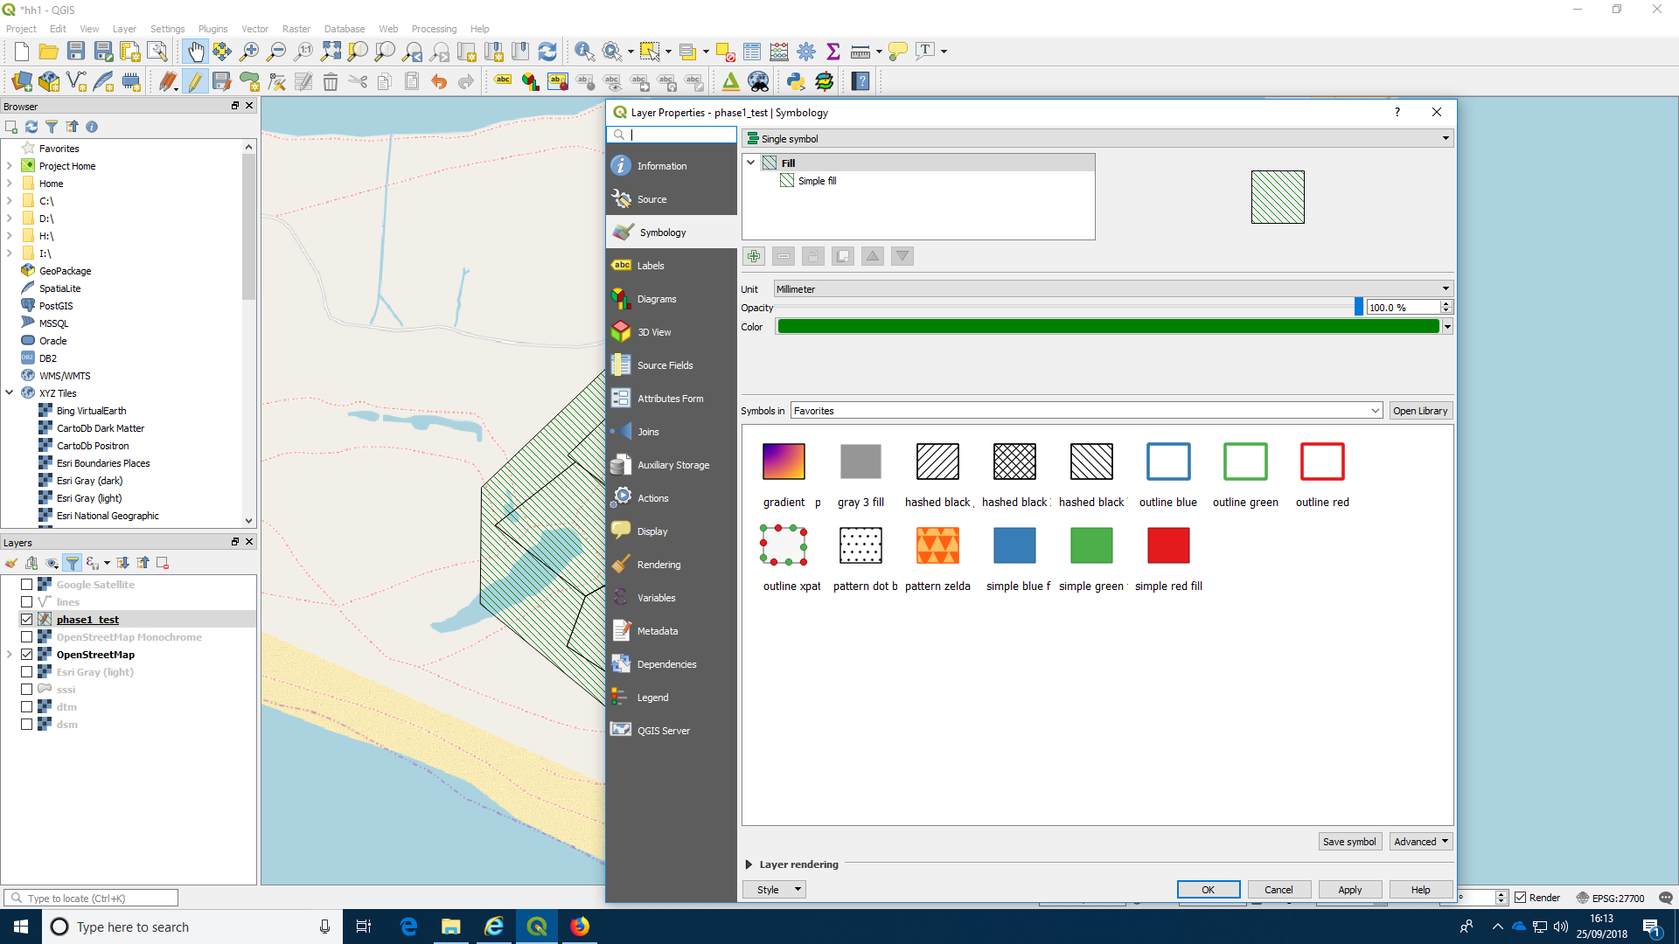
Find symbology on the properties menu. At the bottom of the window there is a button labelled style. Click on this
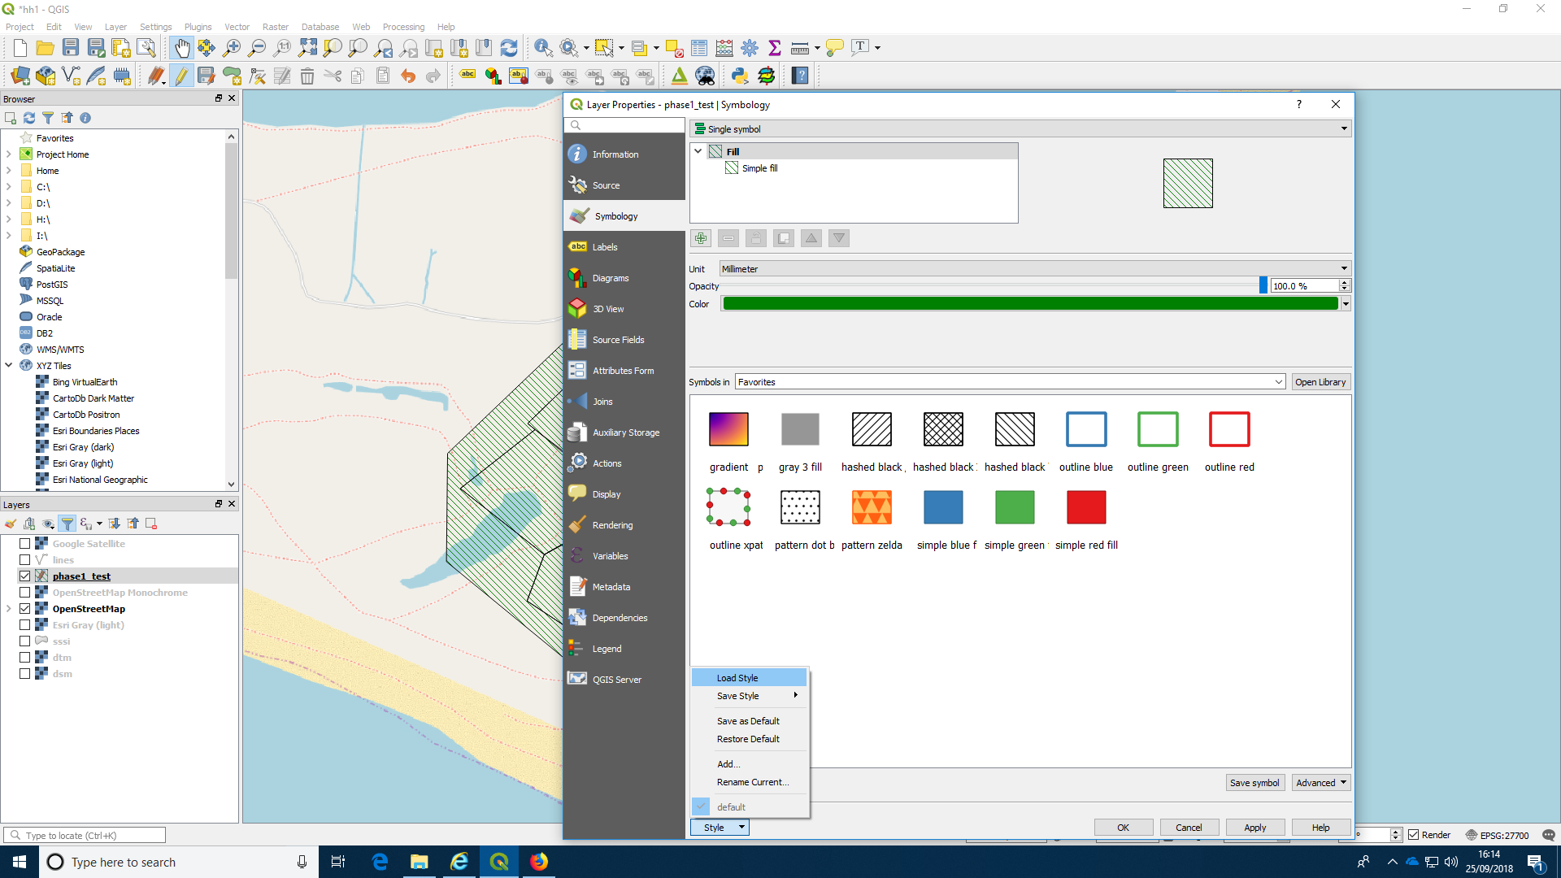

Loading the style sheet colour scheme for the polygons.
This will prompt you to load a style. You should have a phase one style sheet in your project folder. You can download one (there are quite a few available that have been prepared by different people working on phase one mapping) from here.
http://r.bournemouth.ac.uk:82/PhaseOneMapping/QGIS-UK-habitat-syles-for-phase1/
I used this one
http://r.bournemouth.ac.uk:82/PhaseOneMapping/QGIS-UK-habitat-syles-for-phase1/P1%20Habitat%20Survey%20Toolkit%20QGIS%20QML%20Polygon%20Style%20File.qml
You should also download the handbook for phase one mapping for reference.
http://r.bournemouth.ac.uk:82/PhaseOneMapping/pub10_handbookforphase1habitatsurvey.pdf
Make sure you place the style file in the project folder tha you are using.
Now open the style and apply it to the layer.
For this operation to work you will need to have ensured that one of the attributes for the polygons represents the code used for the phase one maps. This is very important as the letters in the attribute text should correspond exactly with those used in the phase one mapping guide. You should check this carefully as this will be needed in the assignment.
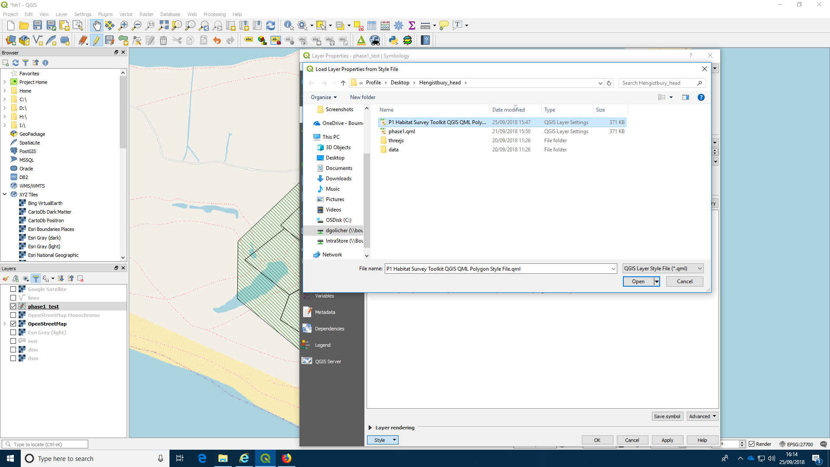
Choose the column that corresponds to the code.
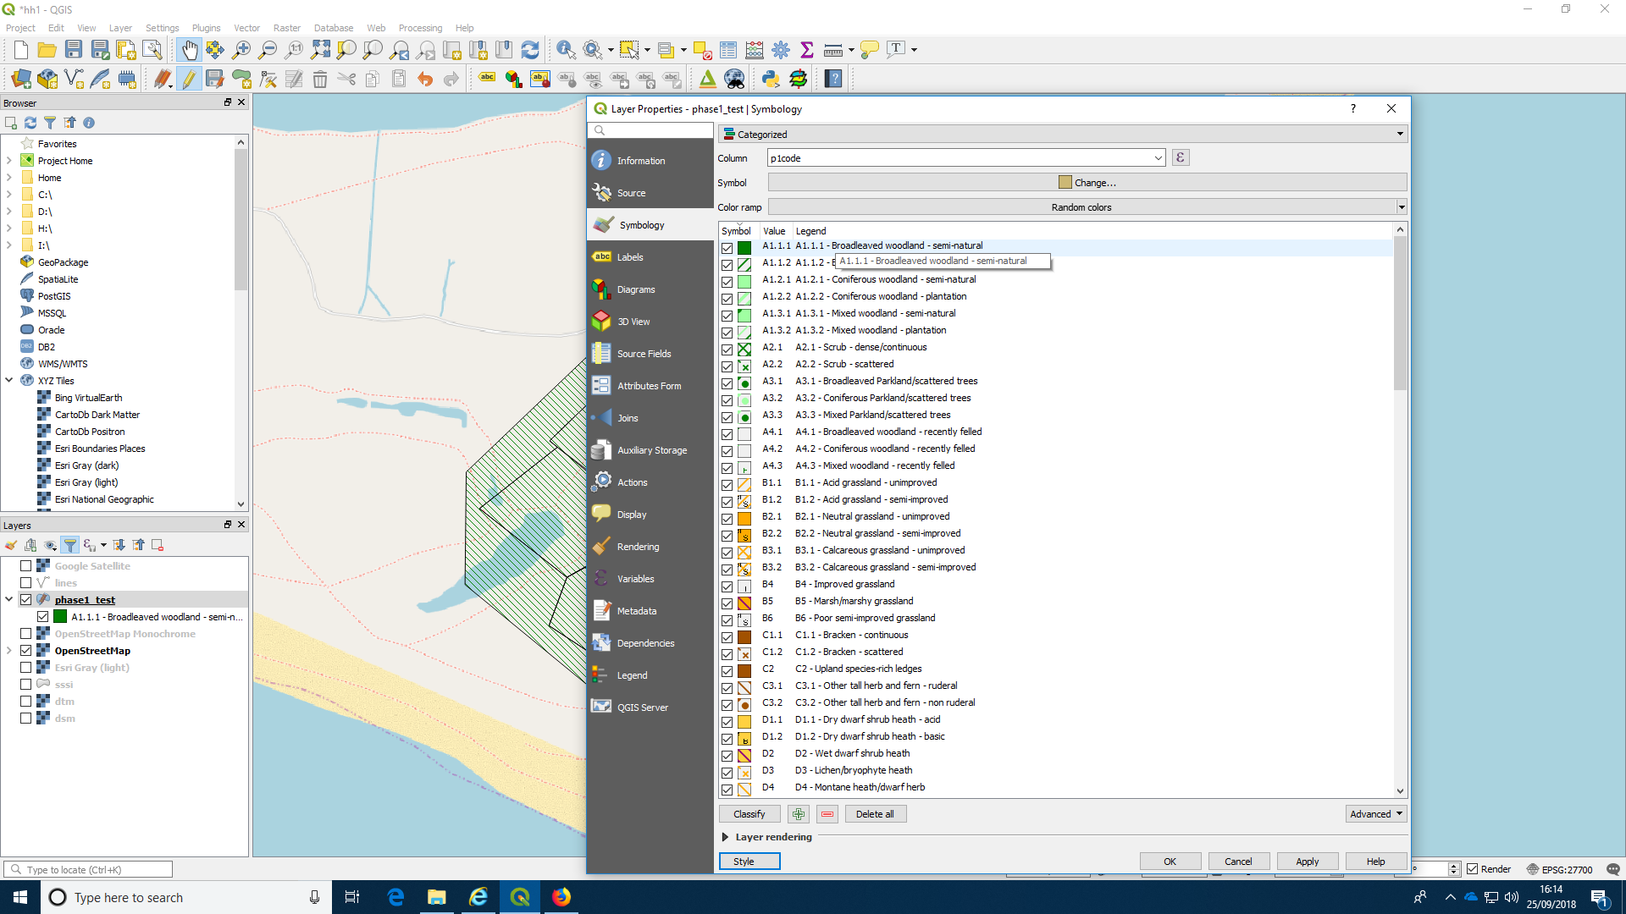
You should see that the polygons have now all changed thier fill colour.
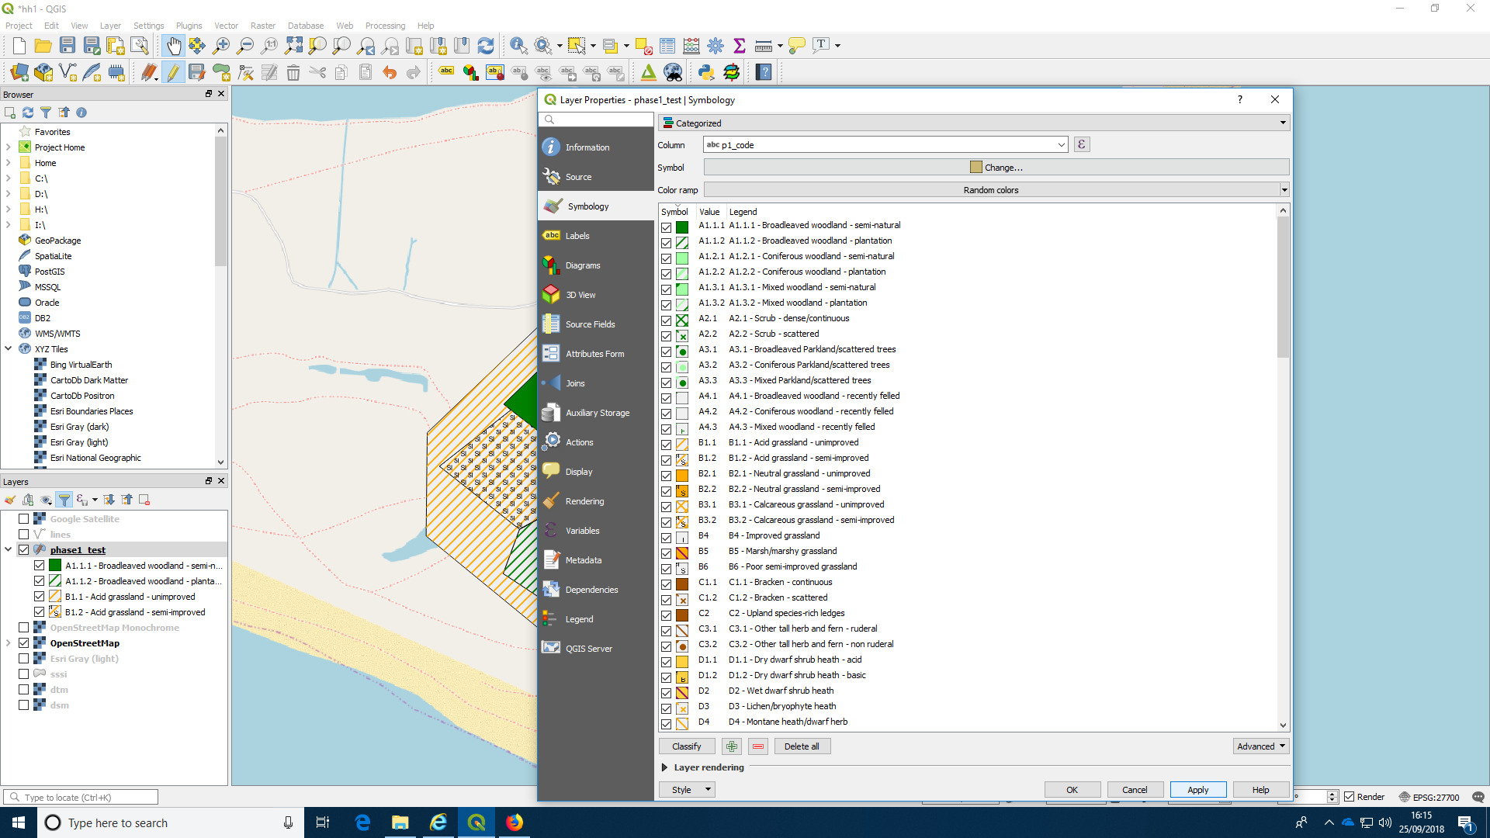

Filtering the visible styles
The style sheet has entries for all the possible phase one habitats. This is rather awkward, as you won’t have used many of these options in your own map. So you can show only the ones that you have actually used by applying the filter (inverted funnel) at the topof the layers panel.
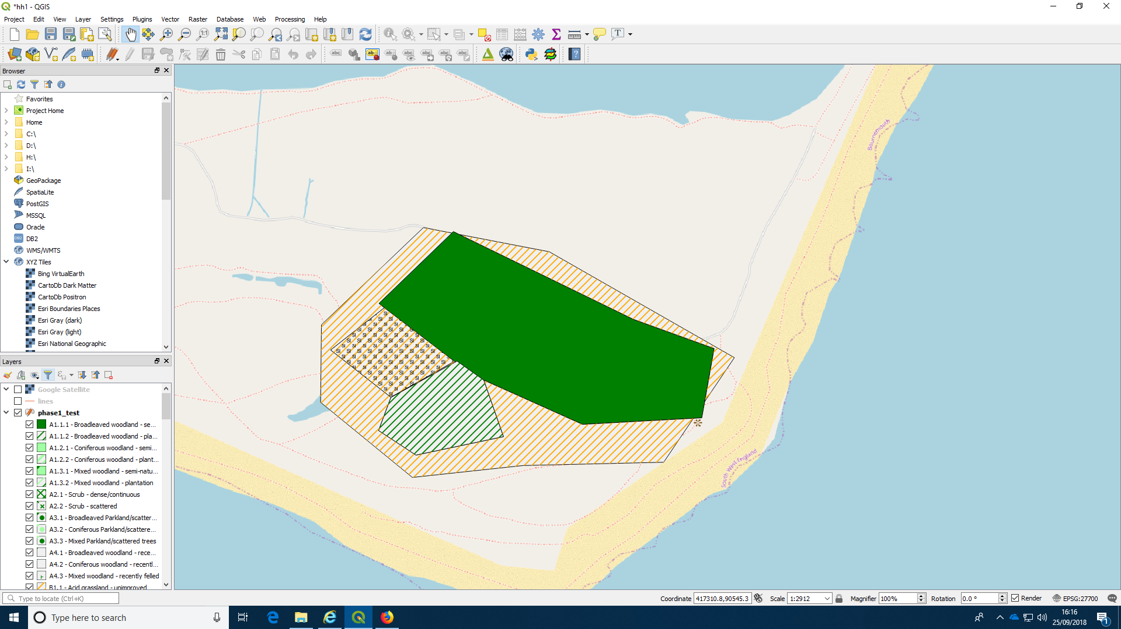
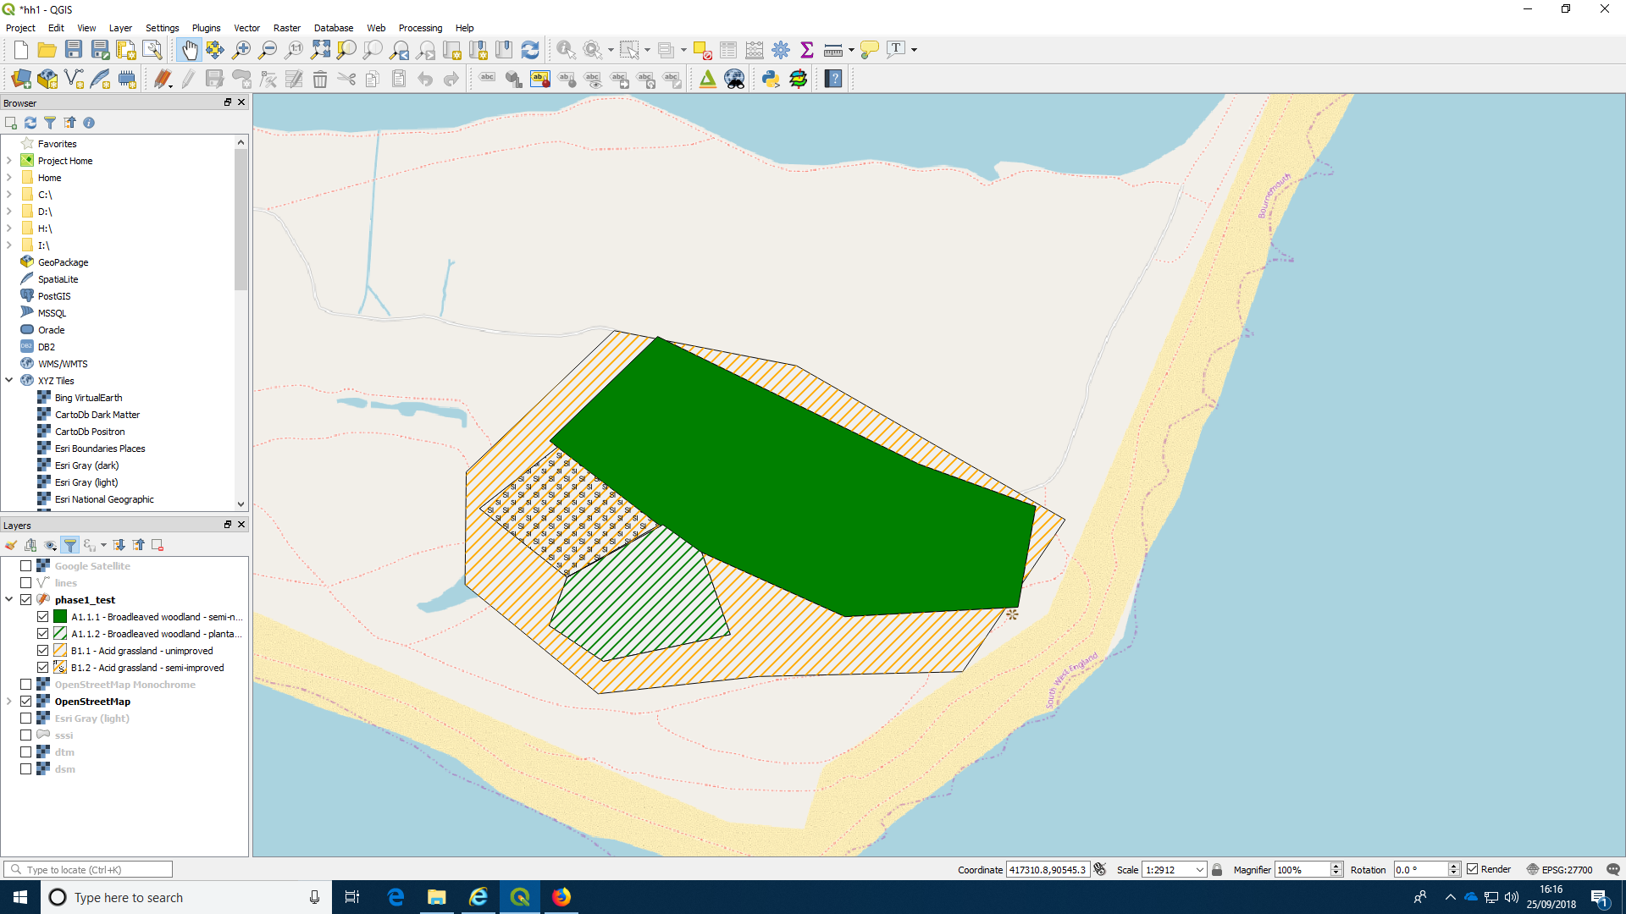

Copying and pasting styles
To illustrate this concept a little further I then ran the buffering and differencing operations shown in the last handout in order to split the polygons by the paths.
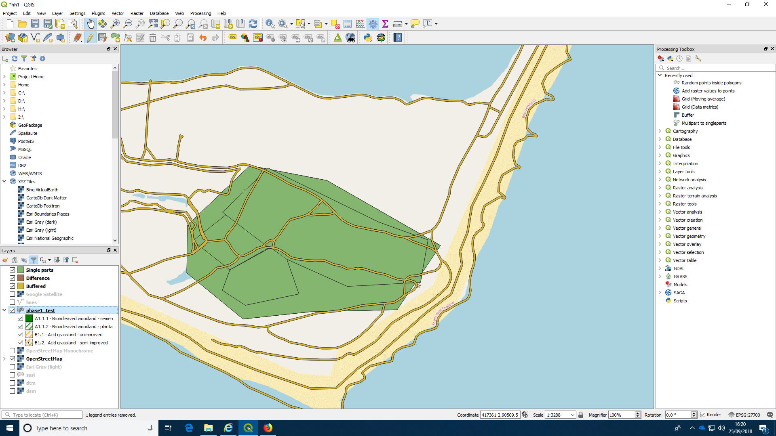
This layer does not yet have a style, as I have just derived it. However by right clicking on the original layer brings up a menu with “styles” included. If you click on this for the original layer you can copy the style.
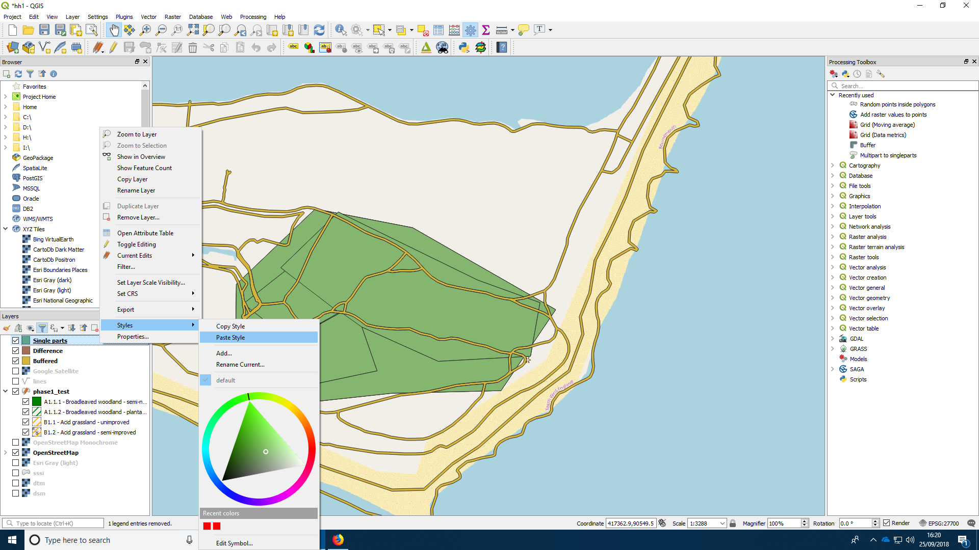
You can then open the menu for the new layer and paste the style into it. The new layer will then be shaded just as the original was.
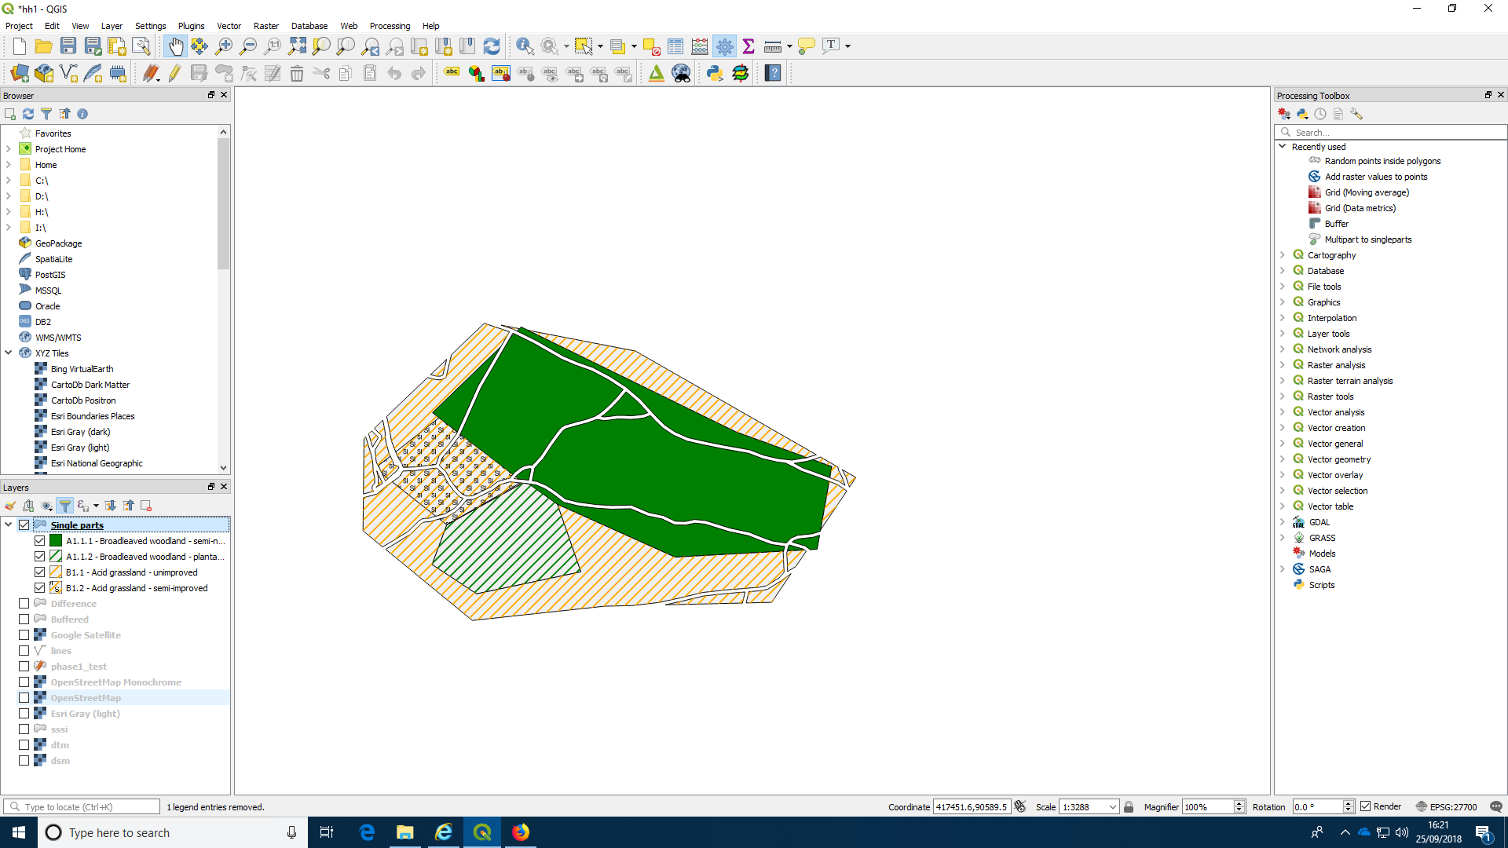

Adding derived attributes
At this point it might be worth including an explanation of how some additional attributes can be added to a digitised layer. It is often useful to know the area of a polygon and the perimeter. These can be added to the layer using the filed calculator.
Right click on a layer nd find the attributes table. When the attributes table is open for editing you will be able to add new attributes to the layer. You may add some of these by typing values or text into the table. However others can be calculated from the geometries. Area and perimeter are obvious examples. The filed calculator buttton is on the top right (third from the end)
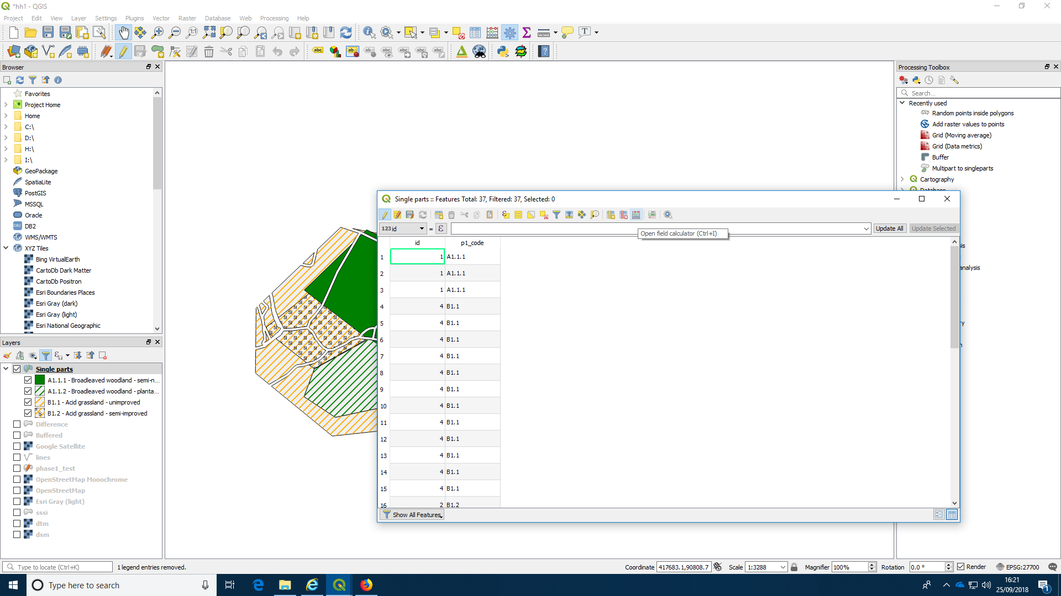
Add a field called “area”. The operator to calculate the area is $area. So if you fill in the window as shown below and press OK you will find the areas have been added. The same can be done for perimeter.
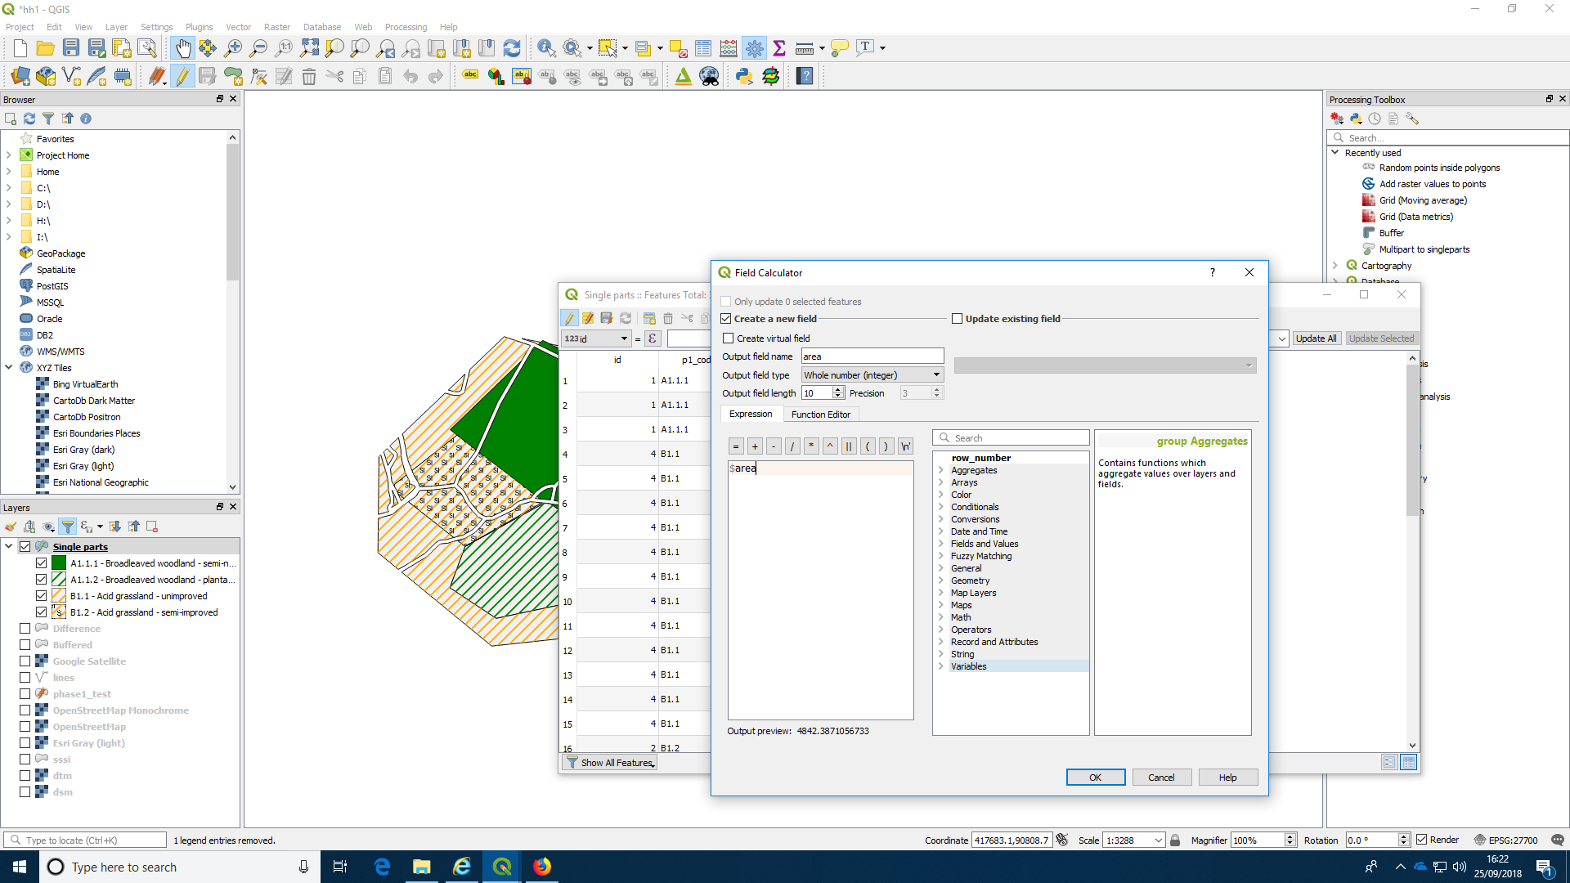
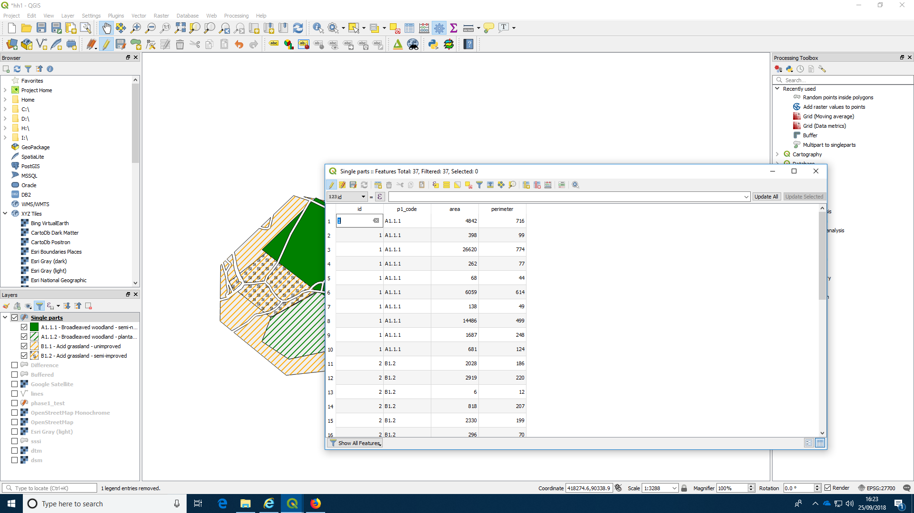
There are many other options for editing and extending the attributes table that you may want to experiment with.

Cartography: Designing a prinatable map
QGIS has a layout manager that can be used to design a map that can be printed on paper. Designing a printable map is something of an art form. There are many possible options and it is up to you to choose those that most suit the application the map will be used for. In general, printed maps should aim for simplicity and clarity. To obtain very professonal results some map makers begin composing the map in GIS and then export the results to an application such as photoshop to touch up the final product.
The key features that you will usually want to show on a printed map will be the scale and a legend that explains the meaning of any shading or symbols on the map.
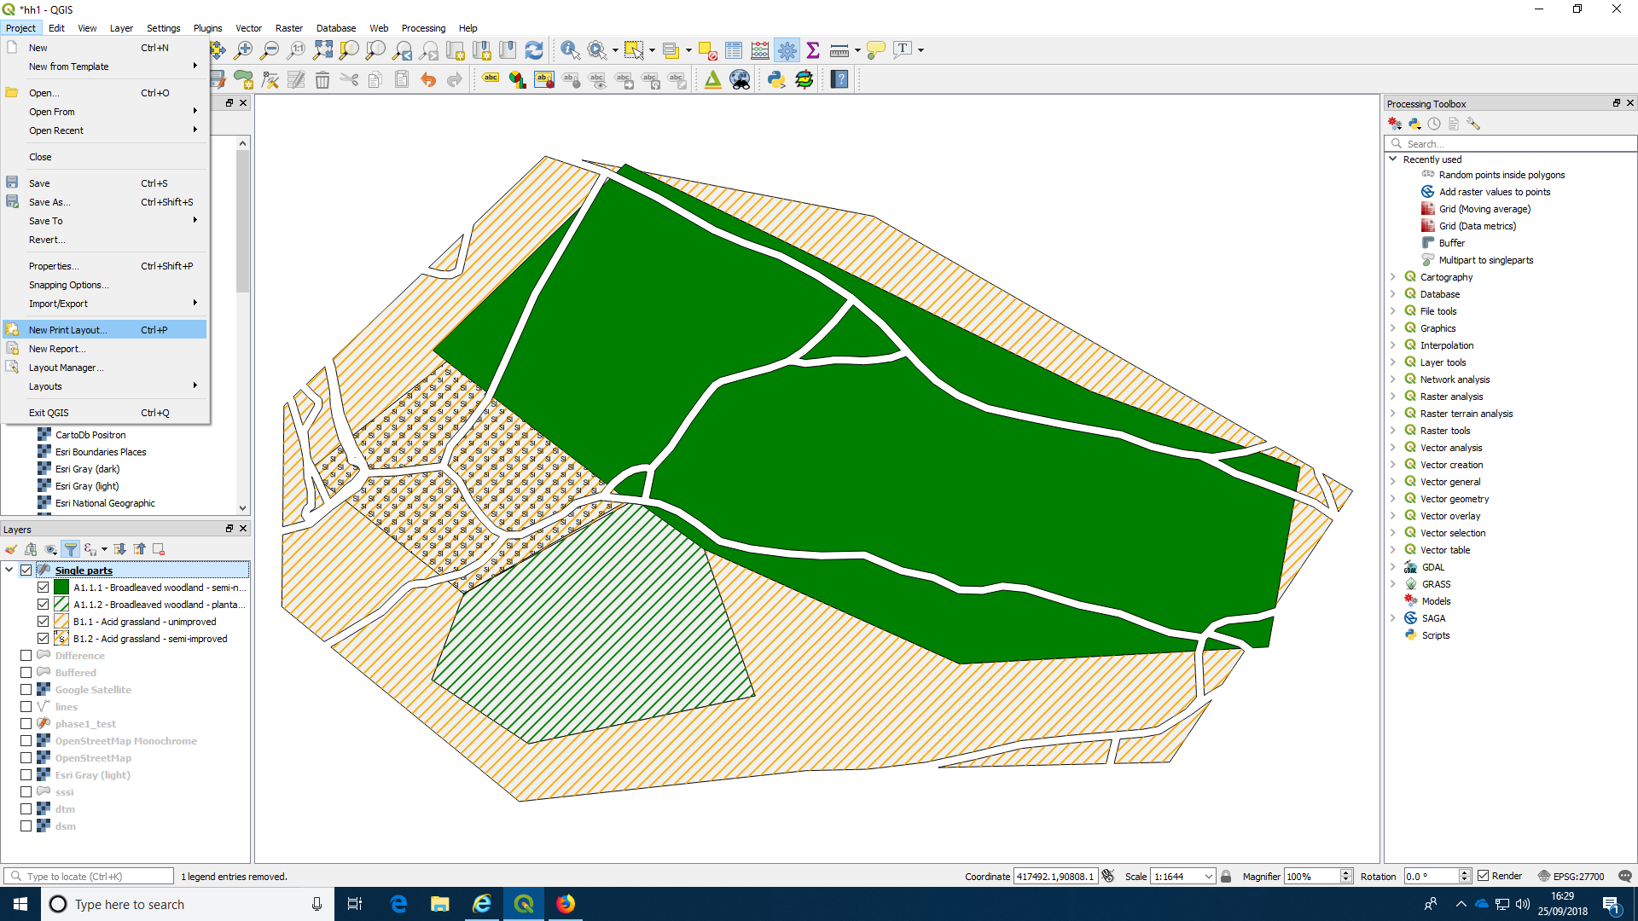
Find the map icon on the left hand side of the composer window and draw a rectangle to include the map as visible in the main window.
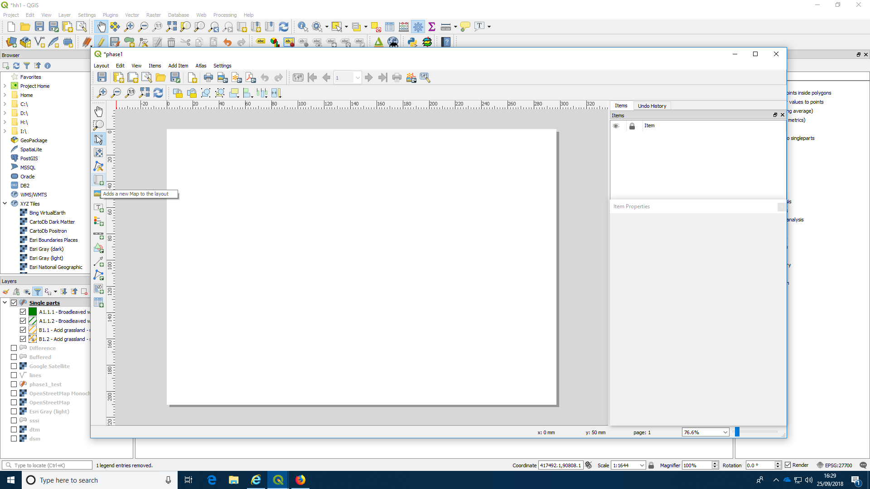
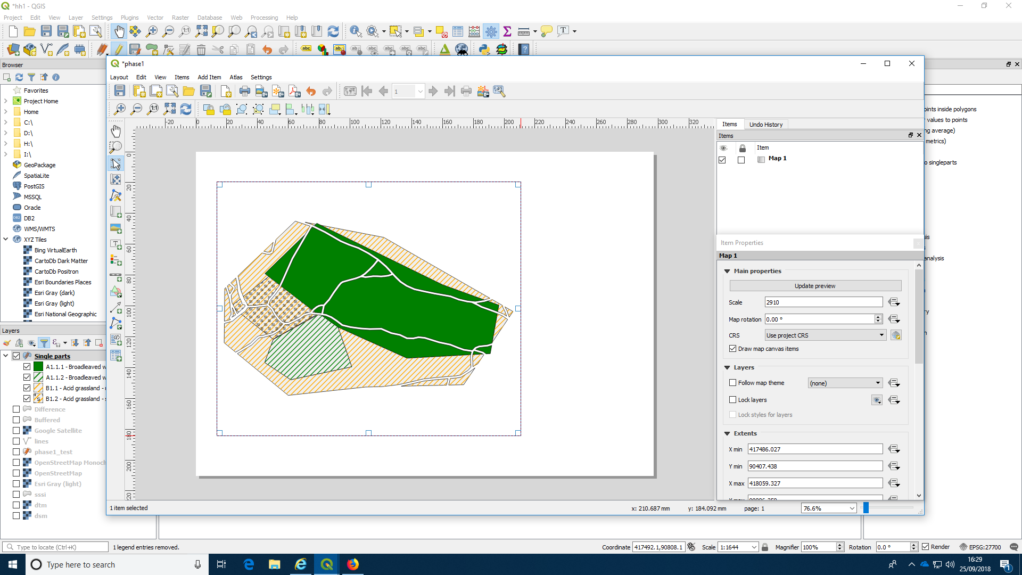
You can add a legend to the sheet.
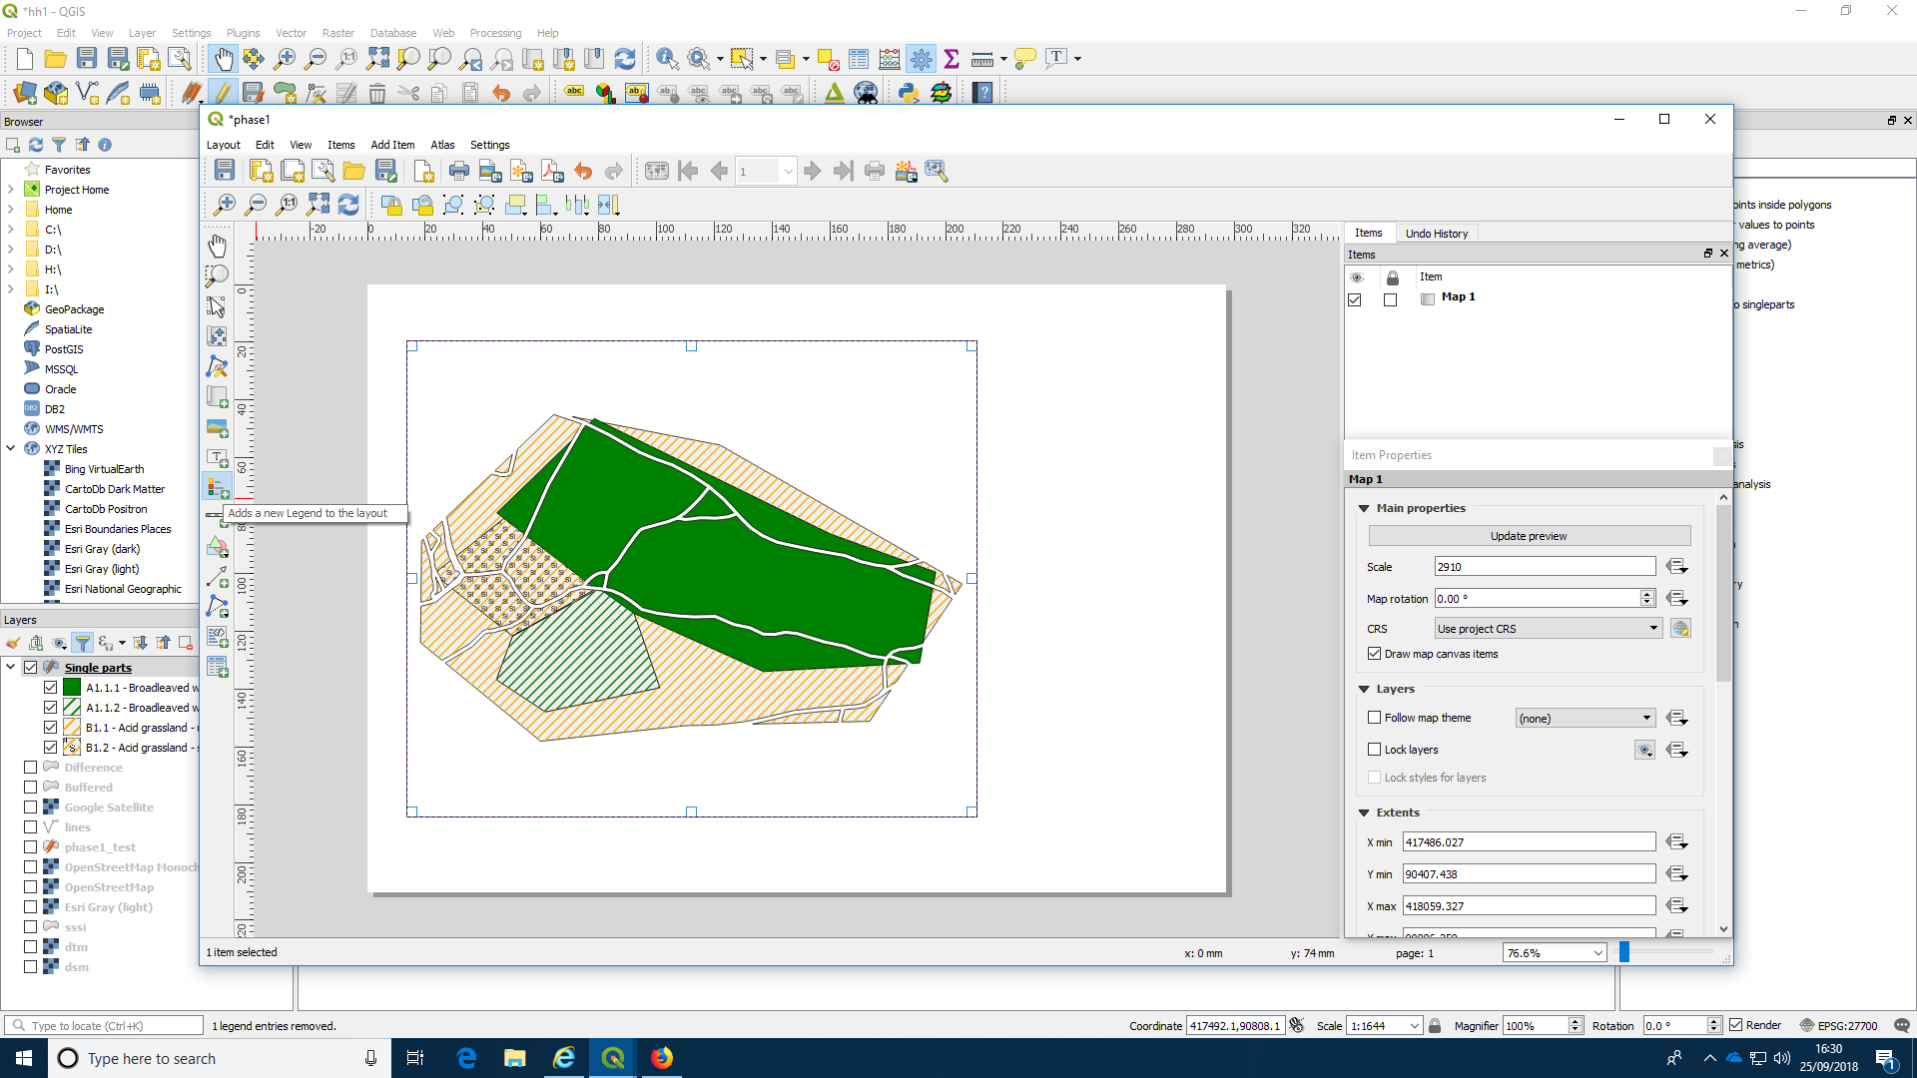
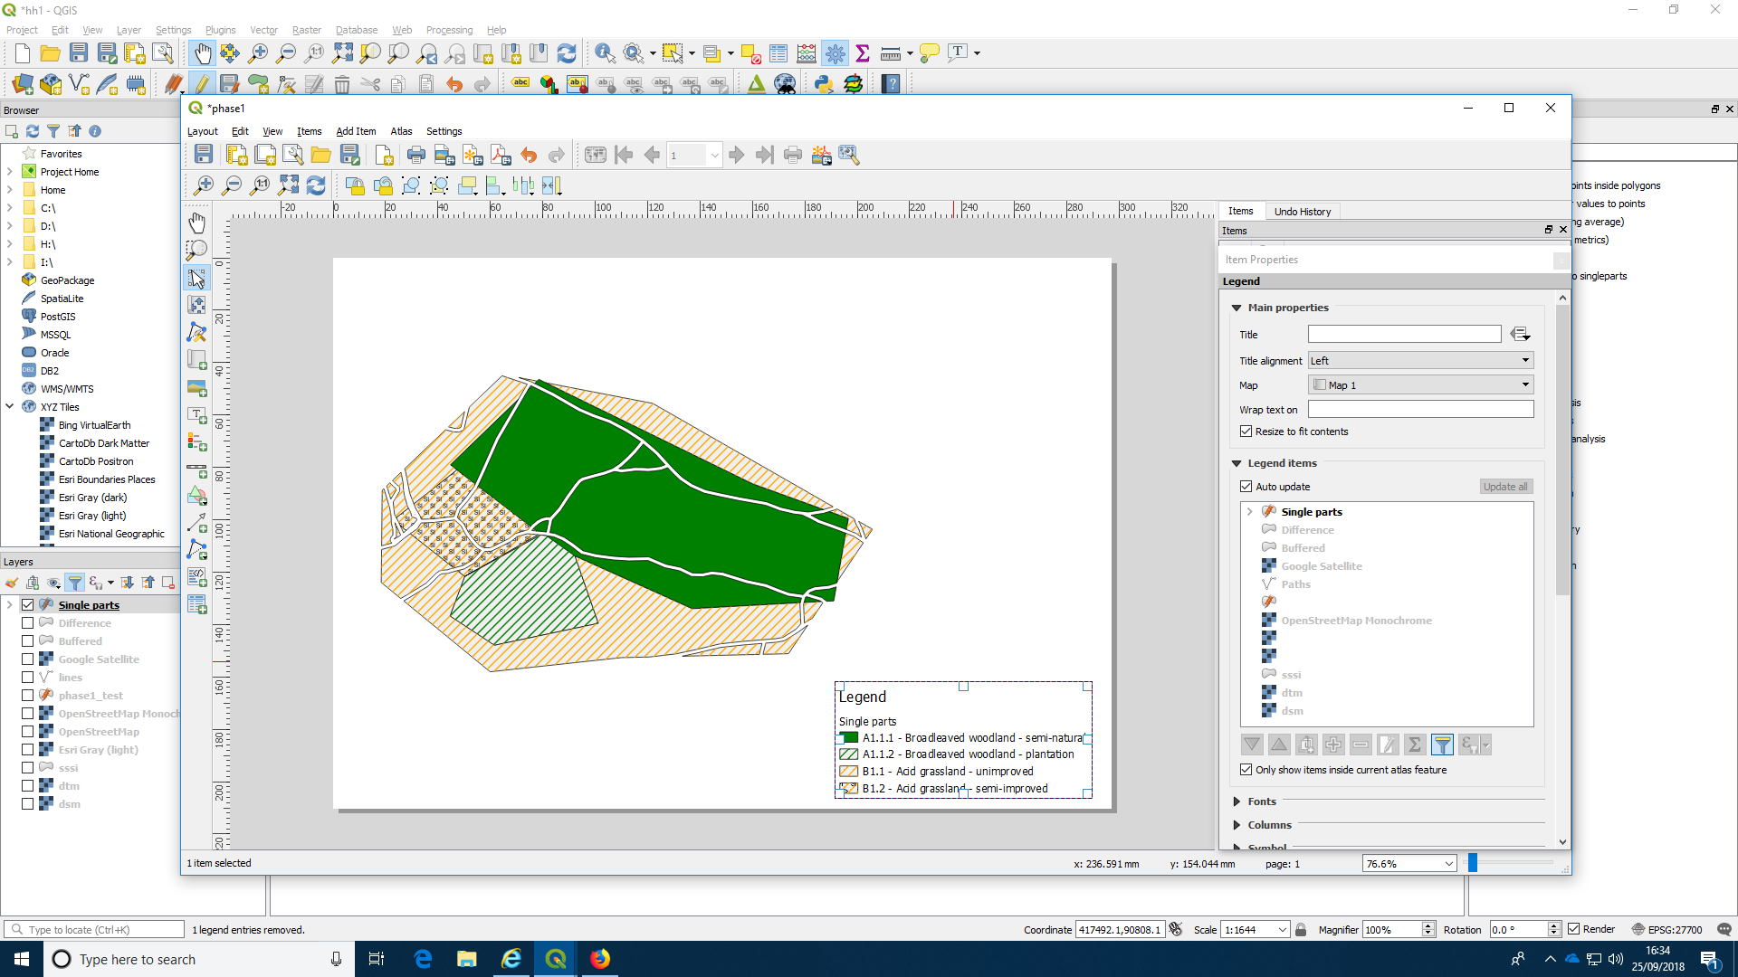
There are options to add graticules with coordinates and scale bars. The best way to learn to use the layout manager is by experimenting.
